INTRODUCTION TO CHAI LMIS

TERMINOLOGY CONCEPTS

MOBILE APP

1. Setup user account
2. Workflows
3. Managing your tablet
4. Getting Started
5. Home Page
6. Workflows
   1. Dispense
   2. Order

* Routine Order
* Emergency Order
* Exceptions
  1. Receive
* Receive from LGA/State Store
* Receive from Zonal Cold Chain Store
* Receive from Other
  1. Losses
  2. Adjustments

1. Logistics Information
   1. Reports
   2. Bin Card
2. Messages

ADMIN PORTAL

1. Configuration – How to setup and how to update.
2. Convention

HELP, FAQ, Troubleshooting

**INTRODUCTION**

DHIS2 LMIS is an android application that is used for stock management at health facilities using the DHIS2 platform. The application can be used on devices running Android 4.0+ and it is optimized for tablets.

The application is built to support offline use for data entry at the facilities and this data is synchronized once a connection is available (3G/2G). It also has a built in fallback of SMS in case Internet connectivity is not available.

TERMINOLOGY

* DHIS
* LMIS
* SMS
* Commodity
* Program

MOBILE APP

**Getting started**

Download and install the latest development version of the application from the following URL: <http://bit.ly/chailmis-latest-dev>

Once installation is complete, you can open the app and you will be taken to the following screen:

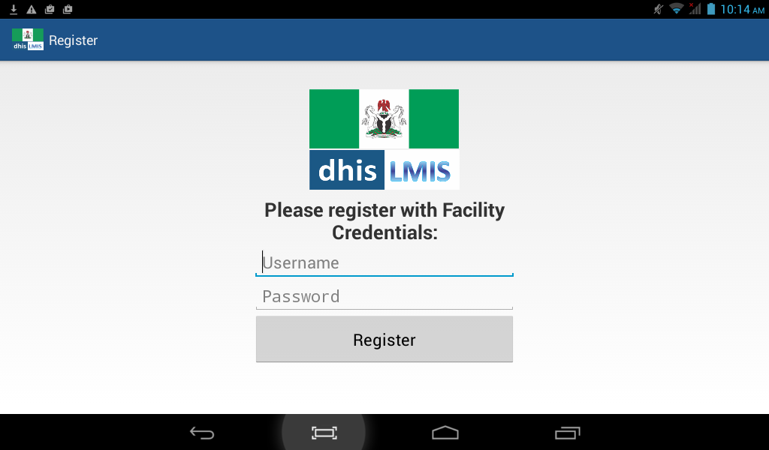

On this screen, you are required to enter your facility credentials that you should have received from the DHIS2 administrator. This is a one-time requirement and once the details are filled in and the register button clicked, the registration process will start and you will see the following screen.

Once the registration is completed you will be taken to the homepage of the application, which is setup as follows

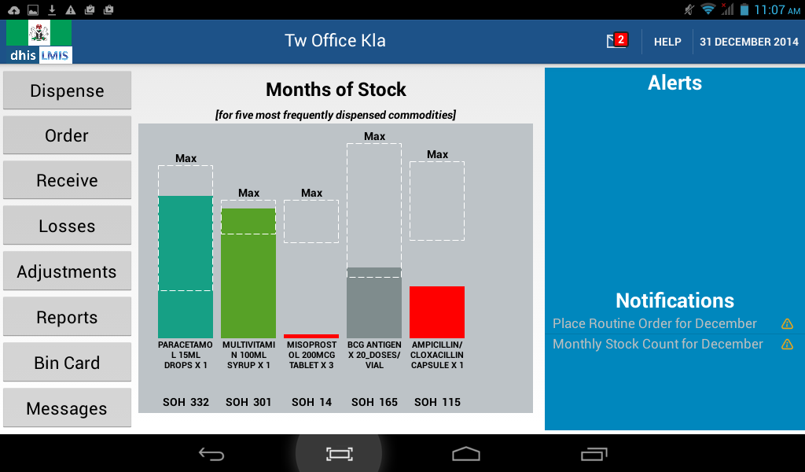

The home page has the following sections:

1. A navigation bar at the top, which has (left to right), the DHIS LMIS logo, the facility name, a clickable alerts/messages link (showing the number of alerts that you have), a link to the help file and today’s date.



1. A clickable list of modules on the left hand side, which represents the list of activities that you can carry out within the application.
2. A graph in the center of the page which displays the months of stock left for the five most frequently dispensed commodities
3. An alerts and notifications area on the right, which displays the alerts and notifications that the user needs to take action upon. The Notification section only appears when notifications are received

COMMON ELEMENTS OF THE APPLICATION

1. Navigation bar layout
2. Background synchronization

MODULE NAME: DISPENSE

The dispense module is used to dispense commodities to patients who have come to the facility. The process for doing this is:

On the home page, select the ‘Dispense’ module by touching the Dispense button. This will take you to a screen similar to the one below where you will enter the details of the commodities that you are dispensing.

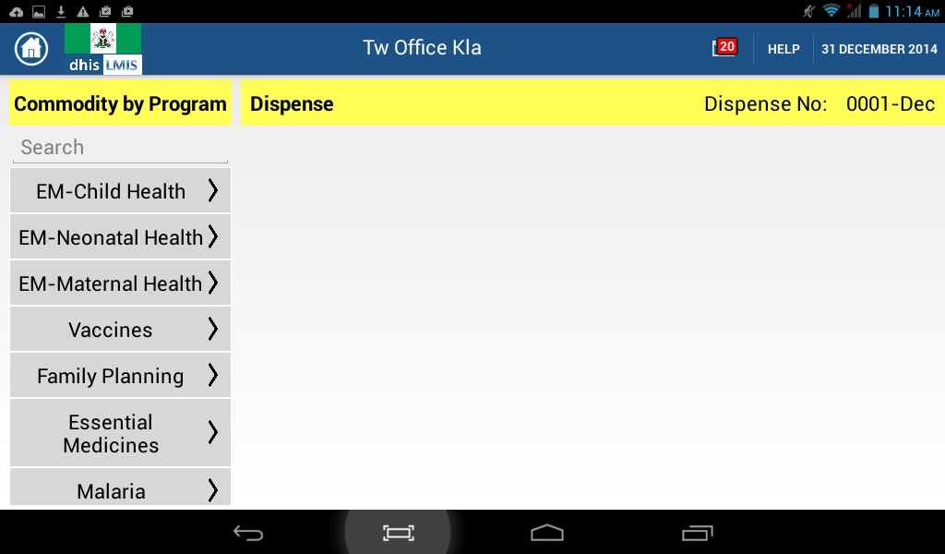

Right below the top navigation bar, you will notice another bar that has a yellow background and has ‘Commodity by Program’ on the left and ‘Dispense’ in the middle with a ‘Dispense No: XXXX-MTH’ on the extreme right where XXXX represents a 4 digit number which is a unique identifier for the current dispense transaction and MTH represents the current month.

To select the commodities that you need to dispense, you have two options:

1. Use the search box right below ‘Commodity by Program’ – Once you start typing in the search box, a selectable list of commodities which have the string you are typing as part of their name will appear beneath the search box and as you continue typing, the list of selectable commodities will be filtered to match the search text. You can select the commodity that you want to dispense at any time by clicking on it. In the example below, typing the letters “pa” identifies Zinc+ORS Copack where the word Copack has the letters Pa in it and Paracetamol that also has the letter Pa in it.

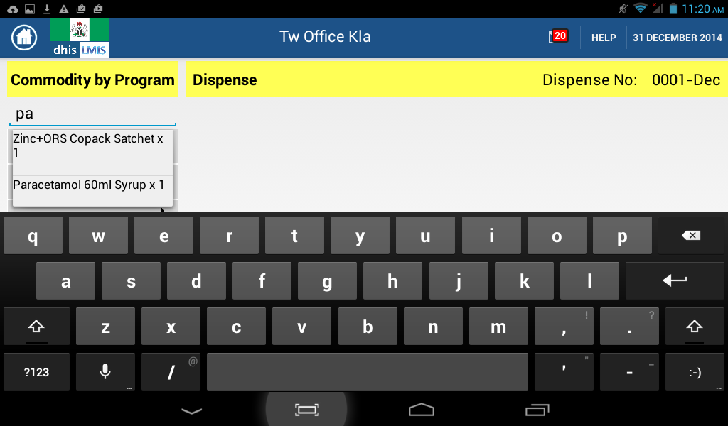

1. Browse to the commodity name through the program. This will require you to know the program under which a commodity is supplied since commodities are categorized by program. Once you select the program from which you would like to dispense, the list of commodities under that program will be brought up as shown in the image below:

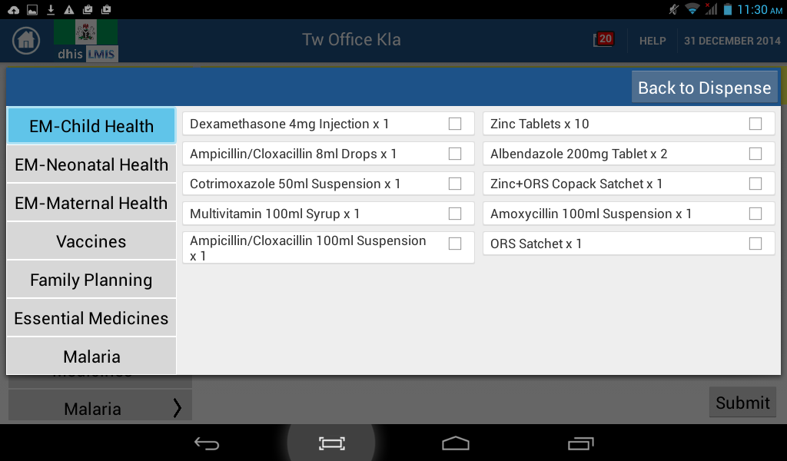

Select the commodities that you would like to dispense by tapping the checkbox at the end of the commodity name. Each selected commodity will change colour to blue and have a blue checkmark next to it. Once you are done, tap ‘Back to Dispense’ and you will be taken back to the original dispense screen but now with a list of the selected commodities.

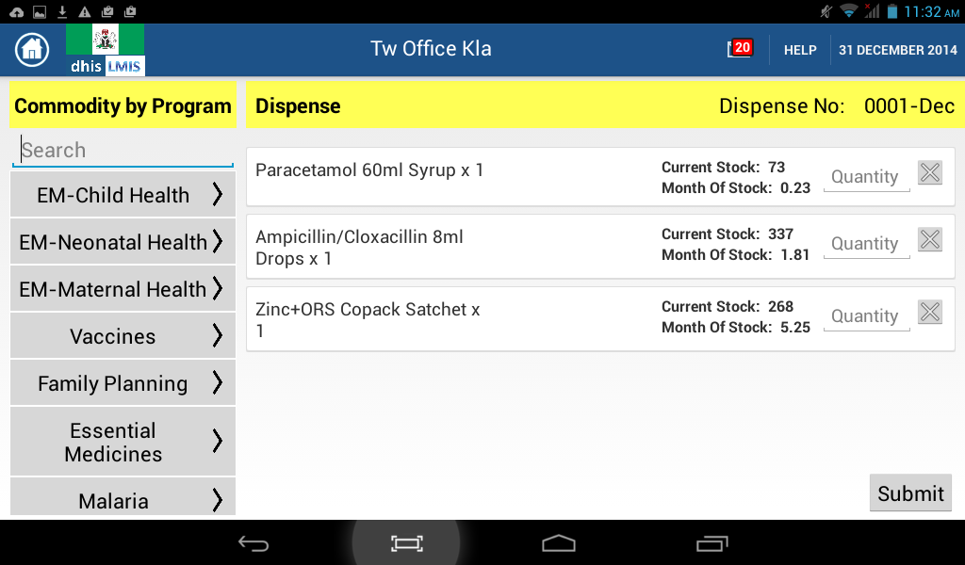

NOTE: Each of the commodities that you have selected to dispense will display the name, the quantity available in stock, the number of months of stock left for that commodity and an input box for you to enter the amount that you are dispensing. Next to the input box is an icon that can be tapped to remove the commodity from the list of commodities being dispensed.

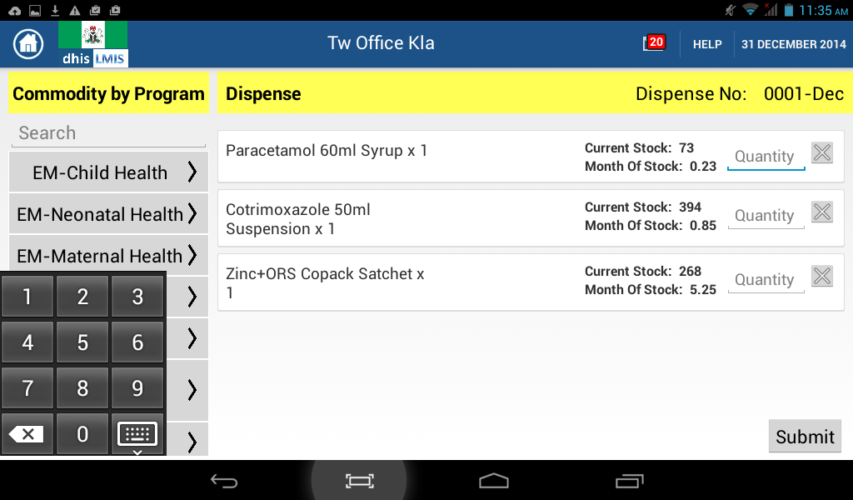

When you select the input box to enter the quantities to dispense, a small numeric only keypad will appear in the bottom left hand corner of the application. Use this to enter the amounts.

Once you have entered the quantities that you are dispensing, tap the ‘Submit’ button in the bottom right hand corner of the application.

Once the ‘Submit’ button is tapped, a confirm screen will appear requesting you to confirm the amounts that you are dispensing. If you see an error, tap the ‘Go back’ button to go back one step and edit the amounts but if you are satisfied with the amounts, tap the ‘Confirm’ button.

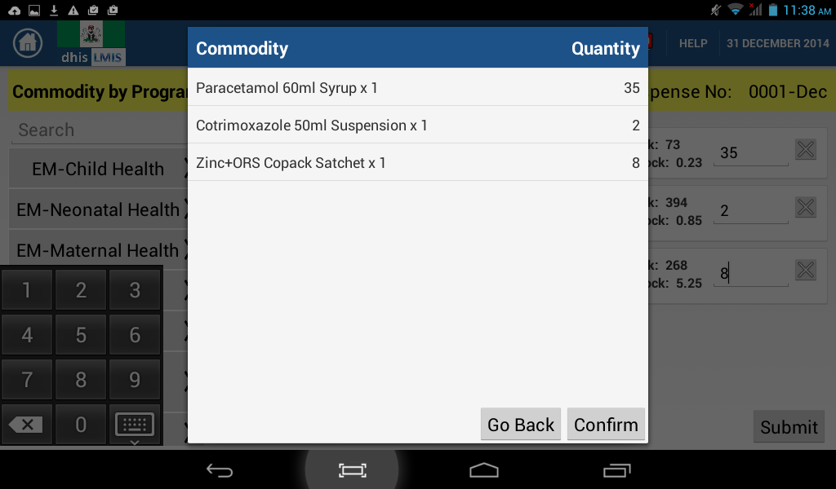

Once you have confirmed the dispense, you will see the following screen as the system is updated and once that is complete, you will be taken back to the dispense page. A new Dispense No will be automatically created for the next dispense transaction.

To return to the homepage of the application, tap the home icon in the top-left corner of the main navigation bar.

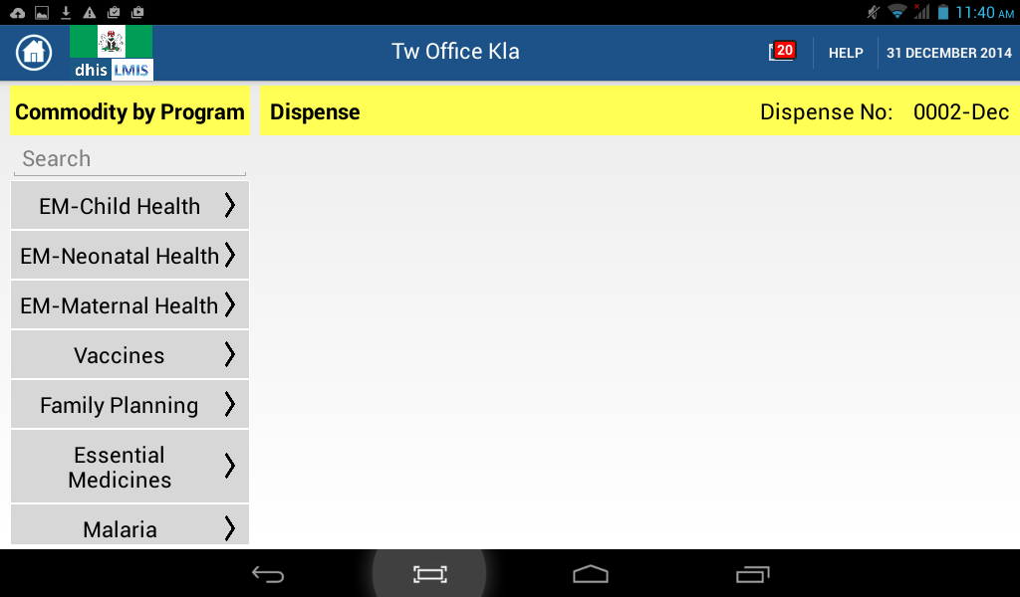

MODULE NAME: ORDER

The order module is used to place orders for commodities that are required in the facility. There are two types of orders:

1. Routine order – Which is placed once every month (and is the default type of order) or a different period based on commodity-specific ordering frequency
2. Emergency order – Which can be placed if the stock on hand of a commodity falls below the minimum stock level or proactively by the user based on other specific reasons.

On the home page, select the ‘Order’ module by tapping the Order button. This will take you to a screen similar to the one below where you will enter the details of the commodities that you are ordering.

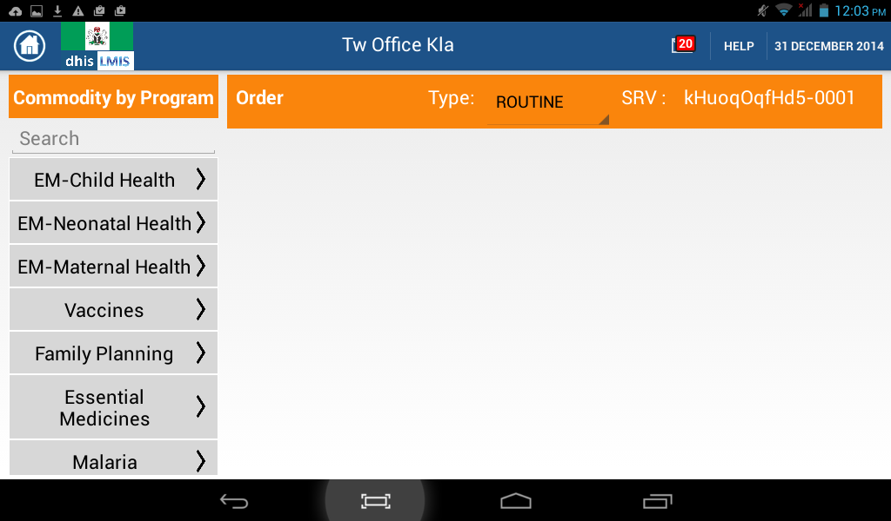

Notice that the page is setup in a similar manner to the Dispense module with the exception that in the bar below the main navigation bar, you will need to specify the type of order. Also, the Dispense number is replaced by an SRV number which is auto-generated by the application for each order.

Routine Order

To place a routine order, select the commodities that you want to order for in a similar manner to how the dispense orders are selected i.e. either using the search box or by browsing to the commodity through the program areas.

Once you have selected the commodities that you want to order, you will be taken to the Order home page which will now look like this:

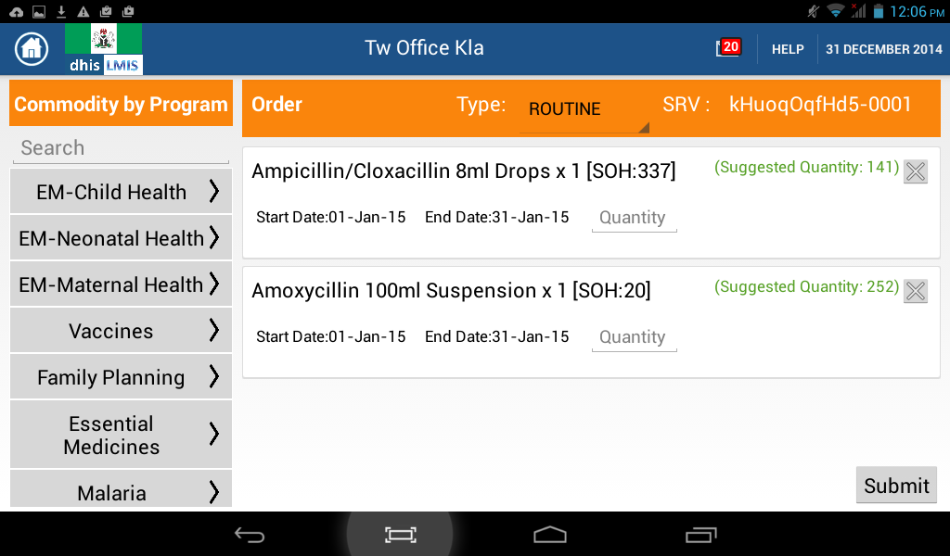

Each commodity that is selected will always display the period for which the order is being made, the current stock on hand and a suggested quantity to order. The suggested quantity to order is derived from calculations that take into account the Average Monthly Consumption, the Safety Stock and Buffer Stock required and the Stock on Hand.

Once you have entered the amounts that you are ordering for and tapped the ‘Submit’ button, you will be taken to a screen where you should confirm the amounts ordered. If you see an error, tap the ‘Go back’ button to go back one step and edit the amounts but if you are satisfied with the amounts, tap the ‘Confirm’ button.

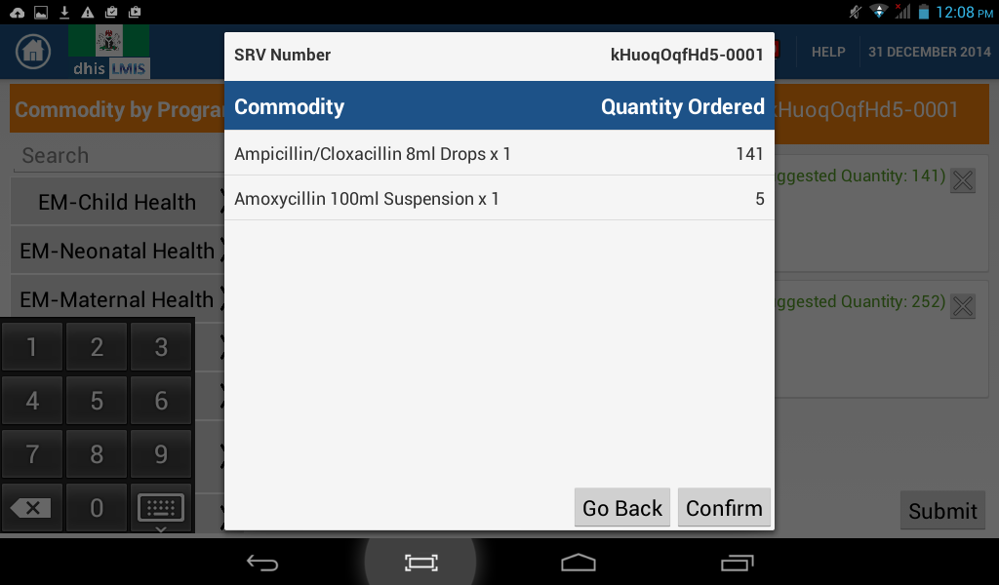

Once you have confirmed the order, you will see the following screen as the system is updated and once that is complete, you will be taken back to the order homepage.

To return to the homepage of the application, tap the home icon in the left-hand corner of the top navigation bar.

Emergency order

An emergency order is characterized by being placed outside the normal ordering cycle for a commodity. To place an emergency order, change the order type to ‘Emergency’ and then select the commodities by following the usual steps:

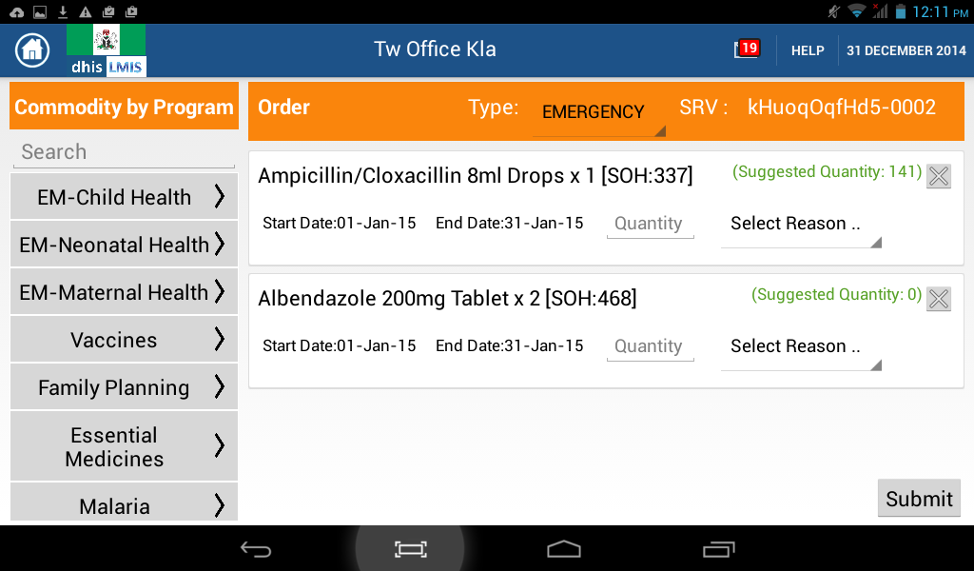

Once you have selected the commodities, you will notice that you have to select a reason for the emergency order. This is done by tapping the ‘Select Reason’ field which will cause a drop down to appear from which you should select a reason explaining the need for an emergency order. There are three reasons that are available:

1. High demand – The demand for the commodity is higher than had been forecast using past consumption trends.
2. Losses – Some of the commodity was lost due to different reasons.
3. Expiries – The commodity’s stock expired before it was dispensed.

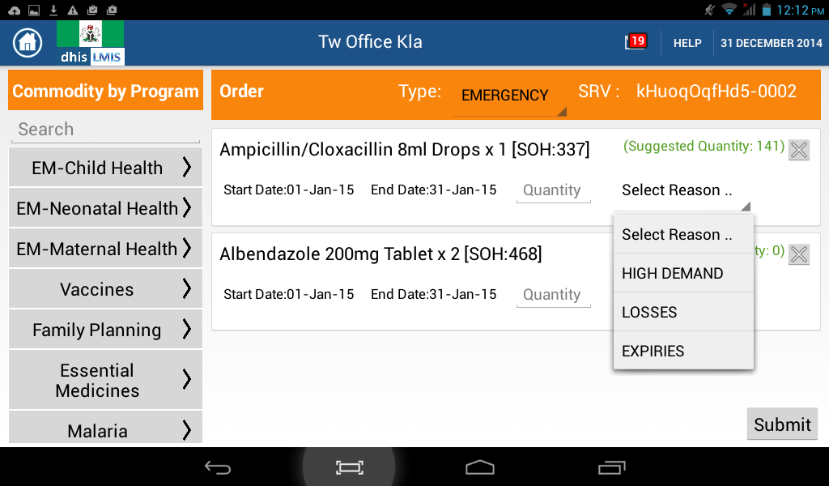

Once you have selected the reasons and entered the commodities, you will be taken to the confirm screen from which you can proceed as before.

**Exceptions**

1. There are some commodities that cannot be ordered through this application and if you try to add them to an order, you will receive an error screen as show below:

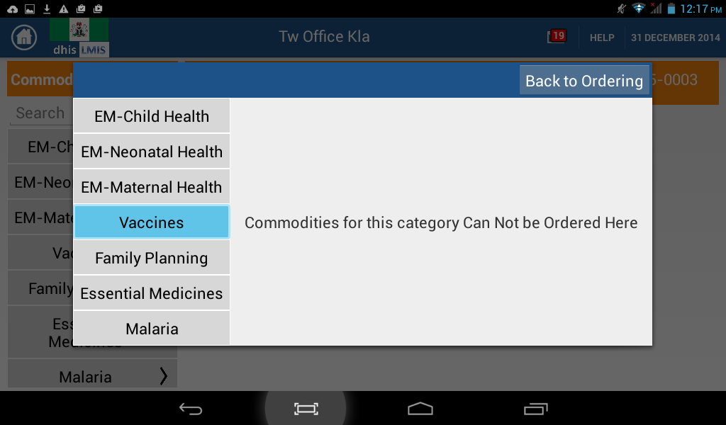

1. For a routine order, if you order an amount greater than the suggested quantity, you will be required to enter a reason for that unexpected quantity and will not be able to proceed before selecting the reason.

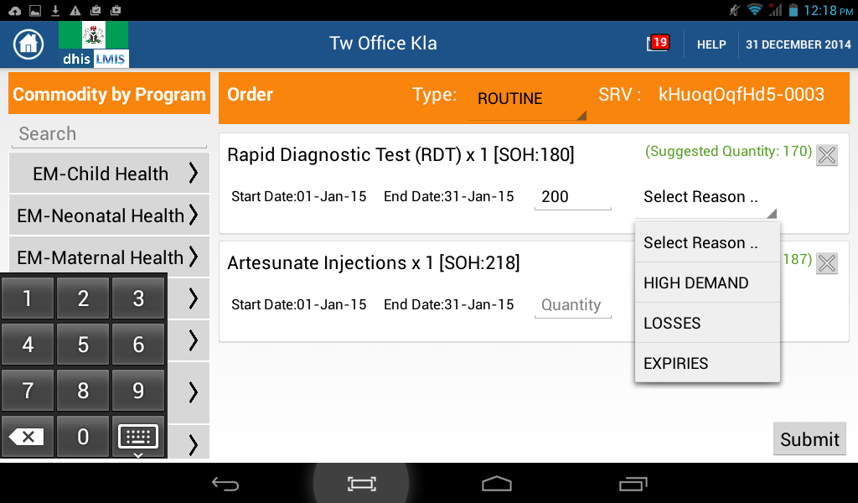

MODULE NAME: RECEIVE

This module is used to receive commodities at the facility.

To enter the module, select it from the home-page by tapping the Receive button. This will take you to a screen similar to the one below where you will enter the details of the commodities that you are receiving.

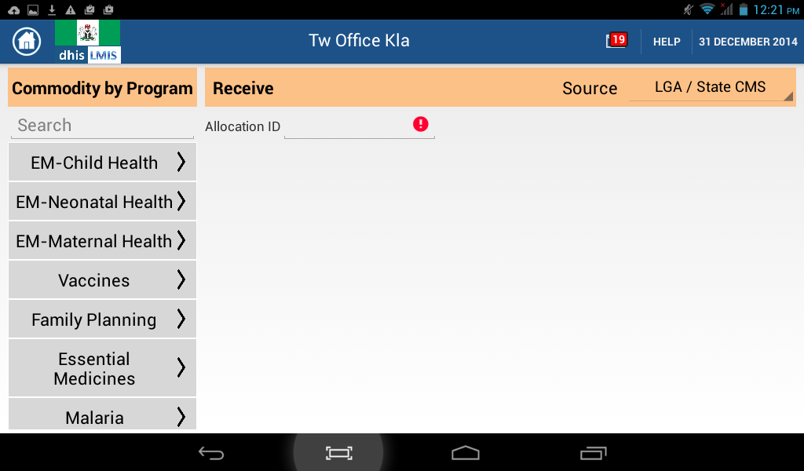

When receiving commodities, there are two additional fields to be aware of:

1. Source: you will have to specify the source of the commodities that you are receiving. There are three possible sources:
   1. LGA/state CMS – This is the default option
   2. Zonal Cold Chain Store – This is only applicable to vaccines
   3. Others
2. Allocation ID – All commodities that are allocated to your facility by the LGA/state CMS will come with an allocation ID against which they will be validated. Because of this, the allocation ID is only required if you are receiving commodities from the LGA/State CMS and if you select any of the other sources, the allocation ID field will disappear.

**To receive commodities from the LGA/State CMS**

* Do not change the default source selection or if you had selected another one, select LGA/State CMS.
* Tap the input box next to ‘Allocation ID’. You will notice that input validation will start happening immediately and you will be prompted to ‘Enter a valid allocation Id’. This error will not disappear until you have entered an ID of the form ‘XX-YYYY’ where XX are two letters and the YYYY represents one or more digits.

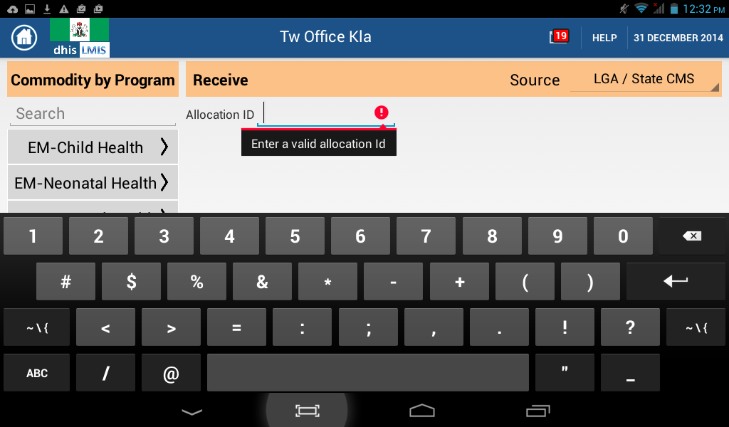

* After entering the allocation Id, select the commodities that you have received following the steps outlined in the dispense module.
* After selecting the commodities, the list will be displayed on the screen and each commodity will have two user input fields (one for ‘Allocated’ which is the quantity that the LGA/State CMS allocated to your facility and the other for ‘Received’ which should be the amount that you received).

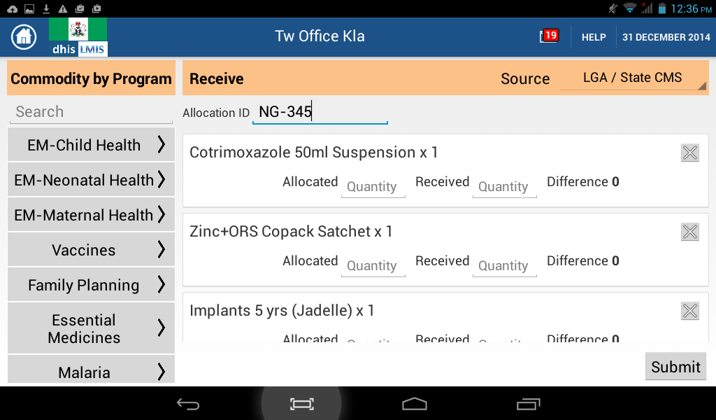

* After entering the amounts, you will be taken to a confirmation screen where you can ‘Go Back’ or ‘Confirm’ the amounts.

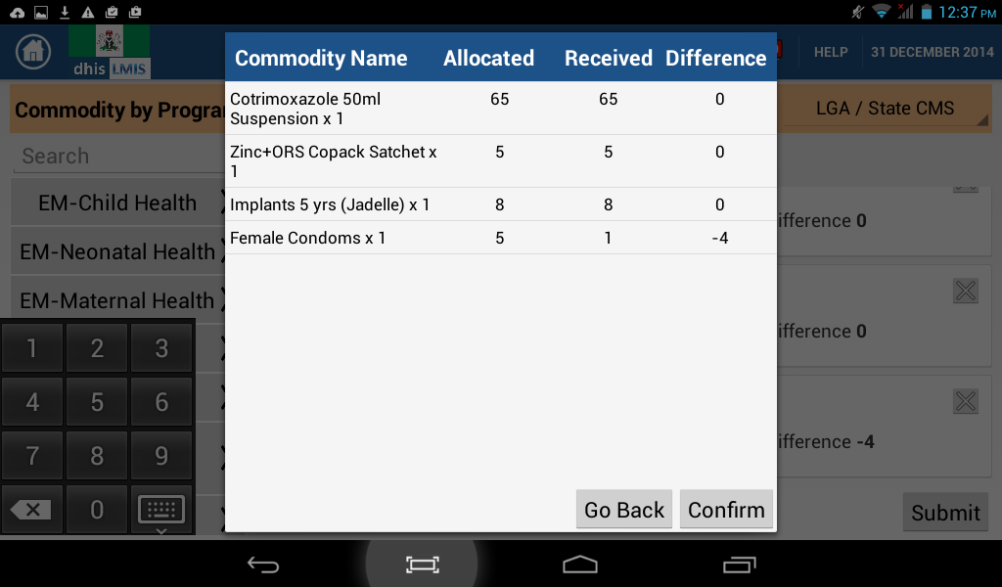

* Once you have confirmed the commodities received, you will see the following screen as the system is updated and once that is complete, you will be taken back to the ‘Receive’ homepage.

**To receive commodities from the Zonal Cold Chain Store/Others**

* Select Zonal Cold Chain store or others as source.
* Select the commodities that you have received following the steps outlined in the dispense module.
* After selecting the commodities, the list will be displayed on the screen and each commodity will have two user input fields (one for ‘Allocated’ which is the quantity that was allocated to your facility and the other for ‘Received’ which should be the amount that you received).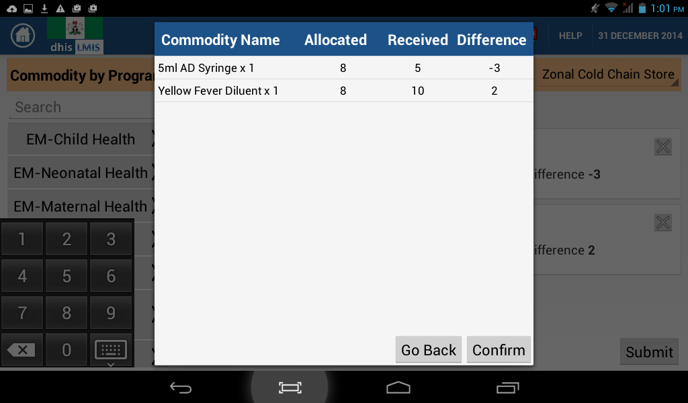
* After entering the amounts, you will be taken to a confirmation screen where you can ‘Go Back’ or ‘Confirm’ the amounts.
* Once you have confirmed the commodities received, you will see the following screen as the system is updated and once that is complete, you will be taken back to the ‘Receive’ page.

Note that at the point of selecting the commodities, if you try to select a commodity that cannot be received from a particular source, you will get a message such as the one shown below:

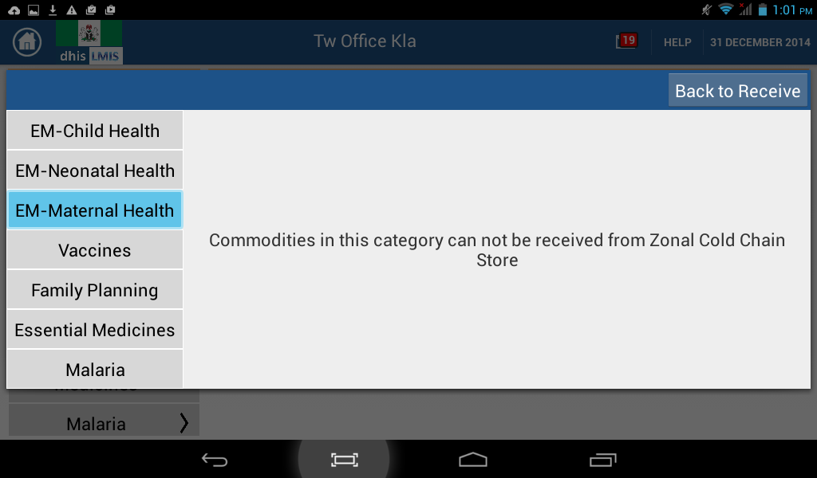

To return to the homepage of the application, tap the home icon in the left-hand corner of the top navigation bar.

MODULE NAME: LOSSES

This module is used to record losses in commodities that could happen for a number of different reasons.

Tap the ‘Losses’ button on the homepage of the application and you will be taken to the following screen:

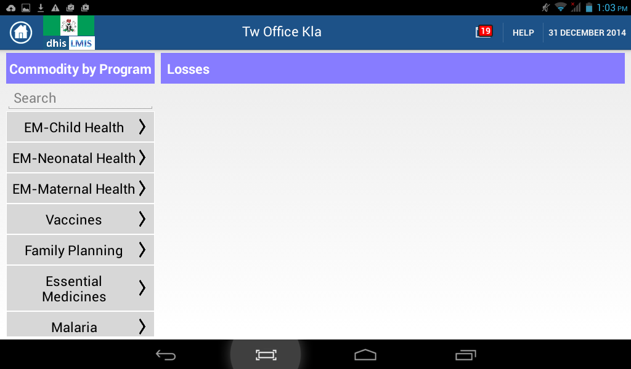

Add the commodities whose losses you want to record by following the same procedure outlined in the previous sections.

The commodities that have been added to the display will have three input boxes labeled ‘Expired’, Wastage and Missing respectively. Enter the amounts of the commodity that have been lost to these reasons in their respective boxes.

Enter zero (0) if you do not have losses in one or two of the three categories of loss.

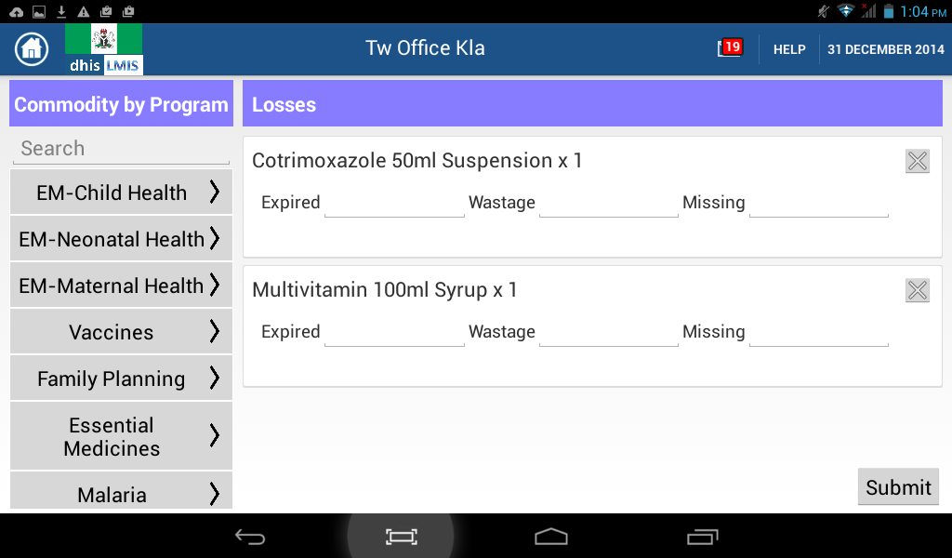

After entering the amounts and tapping ‘Submit’, you will be taken to a validation screen where you can ‘Go Back’ or ‘Confirm’ the amounts.

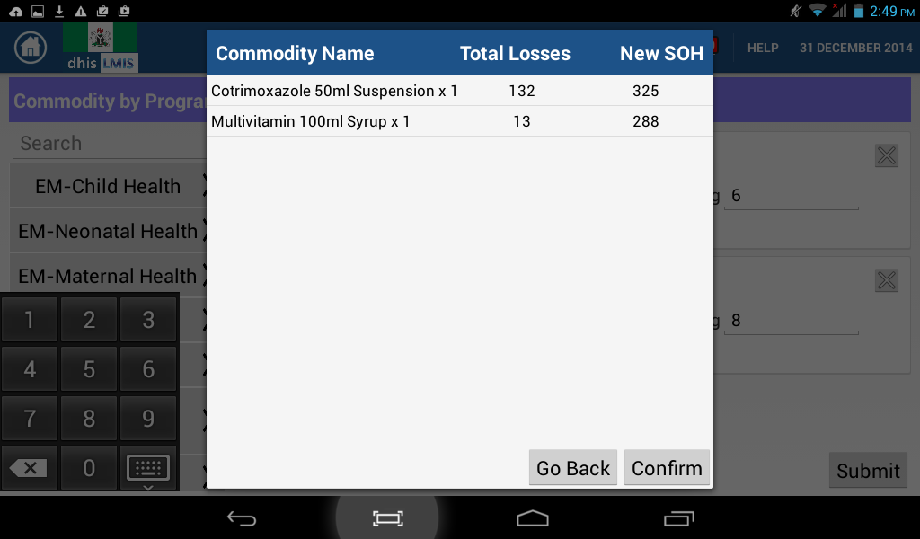

Once you have confirmed the commodities lost, you will see the following screen as the system is updated and once that is complete, you will be taken back to the ‘Losses’ page

To return to the homepage of the application, tap the home icon in the left-hand corner of the top navigation bar.

MODULE NAME: ADJUSTMENTS

This module is used to make adjustments to the stock on hand of the different commodities. Changes in stock can be either positive or negative and are caused by four reasons:

* Physical count is undertaken
* Commodities are received from another facility
* Commodities are sent to another facility
* Commodities are returned to the LGA

When you first navigate to the Adjustments module by tapping ‘Adjustments’ on the application home page, you will be presented with a screen that looks like the following:

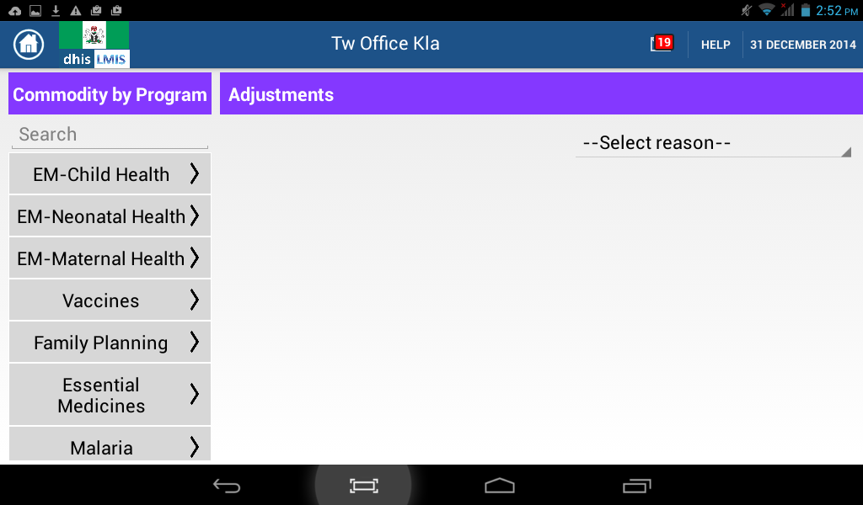

To make an adjustment to the stock, start by tapping ‘Select reason’ which will produce a drop down list of possible reasons from which you can choose.

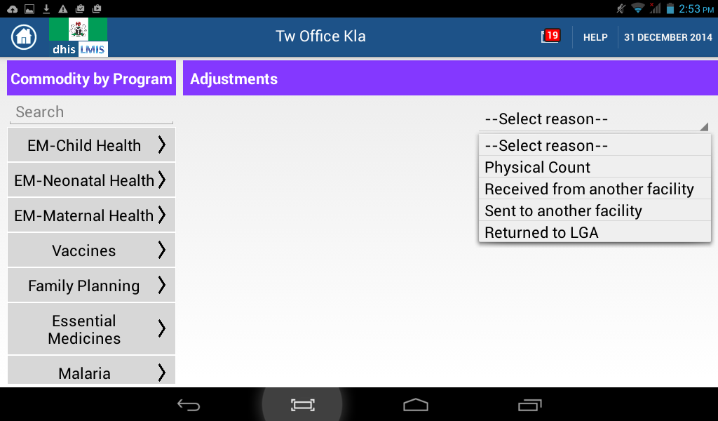

Choose the applicable reason and then go ahead and select the commodities whose stock on hand you want to adjust by using either the search box or by browsing to the commodities through the programs.

The display of the added commodities will differ based on the reason for adjustment selected:

**Physical count**

This will have the name of the commodity, the Current stock on hand, the months of stock left and a provision for you to enter the new quantity counted.

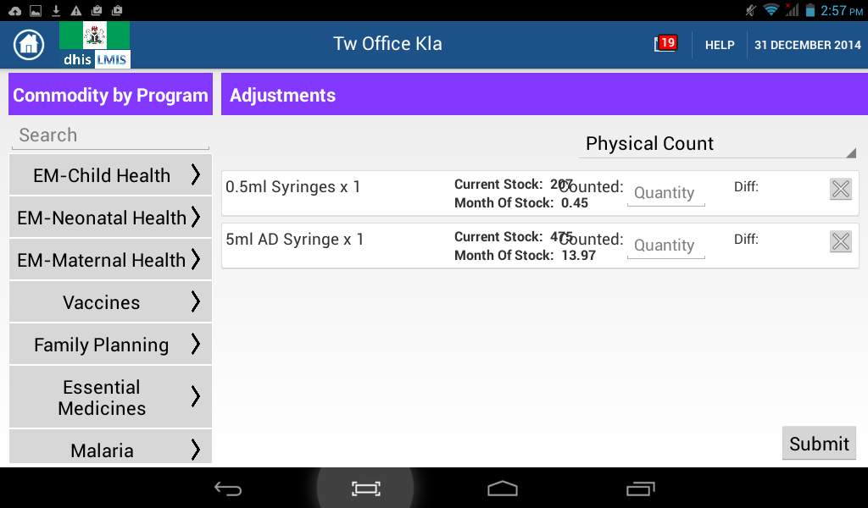

**Received from another facility**

This will have the name of the commodity and a provision for you to enter the amount allocated which can be found on the delivery note and that received from the facility which sent the commodities.

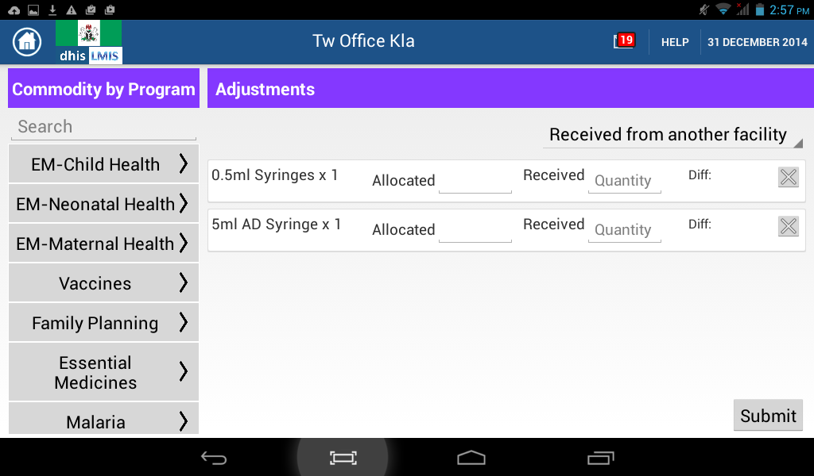

**Sent to another facility**

This will have the name of the commodity, the current stock on hand, the months of stock left and a provision for you to enter the amount of stock that you are sending to another facility.

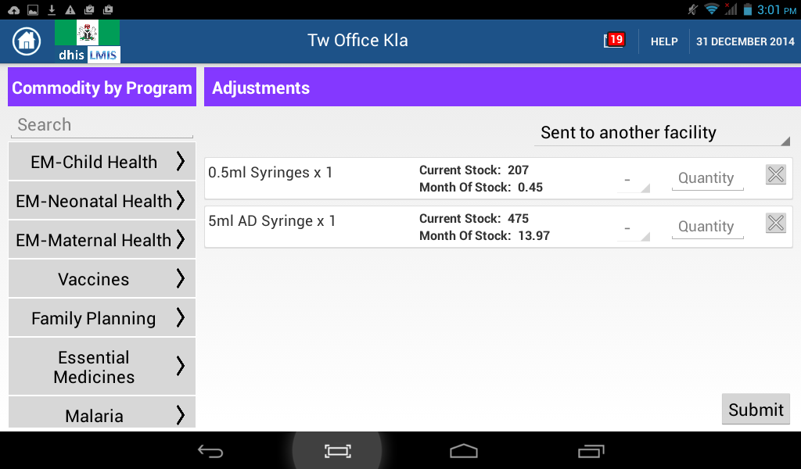

**Returned to LGA**

This will have the name of the commodity and a provision for you to enter the amount of stock that you are sending back to the LGA.

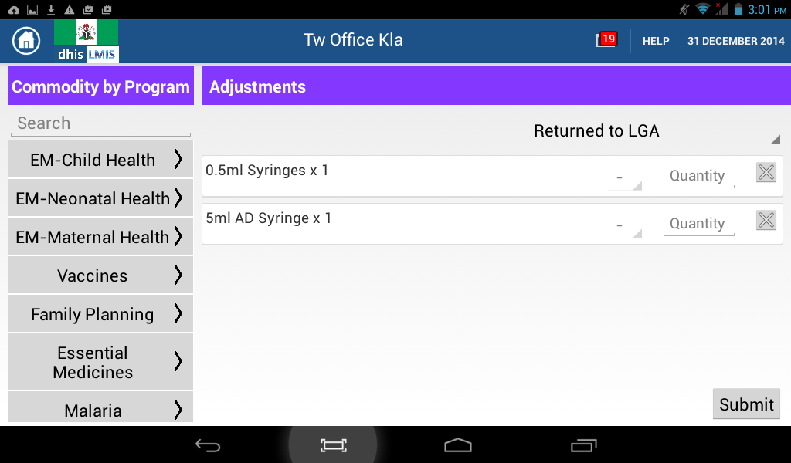

Once you have entered the amounts and tapped ‘Submit’, a confirmation screen will be displayed for you to verify the amounts. This screen will have the following fields:

* Commodity – Which specifies the commodity to which this adjustment applies
* Type – Whether this is a –ve or a +ve adjustment
* Reason
* Adjusted quantity – The amount you have entered
* New SOH – The new stock on hand after this adjustment.

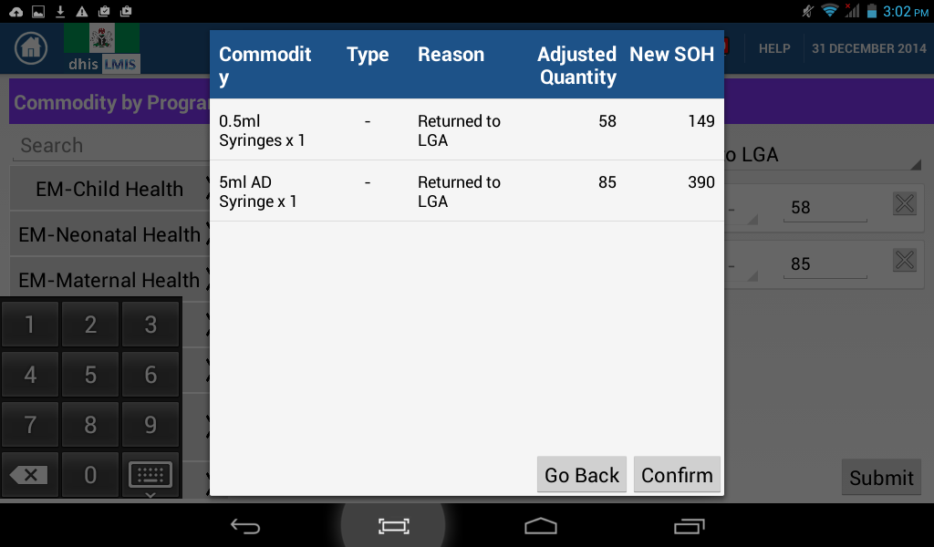

Tap confirm and you will get a ‘Saving’ dialogue after which you will be taken to the ‘Adjustments’ page.

Return to the homepage of the application by tapping the home icon in the left-hand corner of the top navigation bar.

MODULE NAME: REPORTS

This module is used to view reports on the movement of commodities in the facility. Navigate to it by tapping ‘Reports’ on the homepage of the application. You will then be taken to a screen that looks like this:

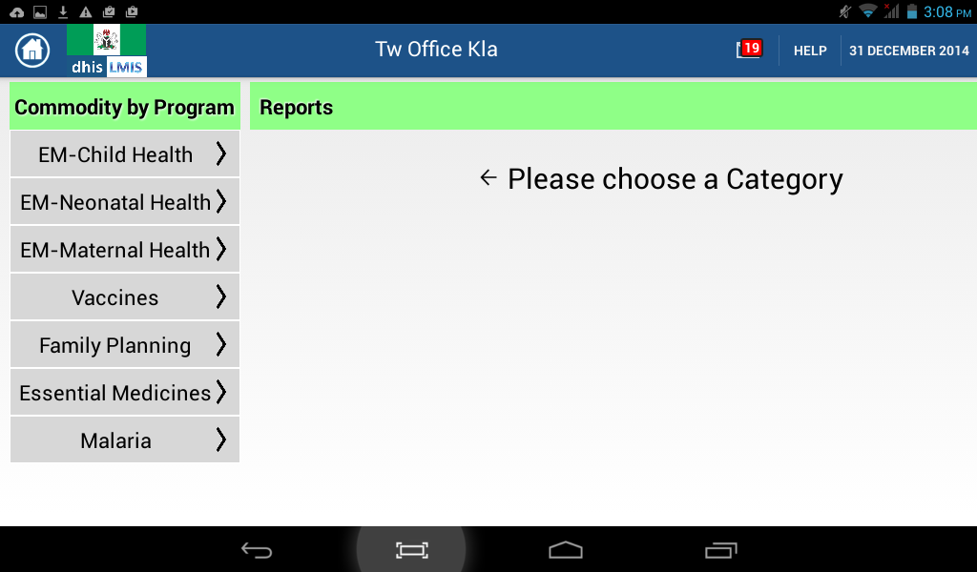

Reports are organized by program area and to view the report types available under each program area, select the Program area on the left hand side of the application.

The report types available by program are:

|  |  |
| --- | --- |
| PROGRAM AREA | REPORT TYPES |
| EM – Child Health | 1. Facility Stock Report 2. Facility Consumption Report RH1 |
| EM – Neonatal Health | 1. Facility Stock Report 2. Facility Consumption Report RH1 |
| EM – Maternal Health | 1. Facility Stock Report 2. Facility Consumption Report RH1 |
| Vaccines | 1. Monthly Health Facility Devices/Other Materials Utilization Report 2. Monthly Health Facility Vaccines Utilization Report |
| Family Planning | 1. Facility Stock Report 2. Facility Consumption Report RH1 3. Facility Consumption Report RH2 |
| Essential Medicines | 1. Facility Stock Report 2. Facility Consumption Report RH1 |
| Malaria | 1. Facility Stock Report 2. Facility Consumption Report RH1 |

Once you have selected the report type that you want, select the different parameters at the top of the report and then tap ‘Load Report’ to view the required details. Examples of the ‘Facility Stock Report’ are provided below:

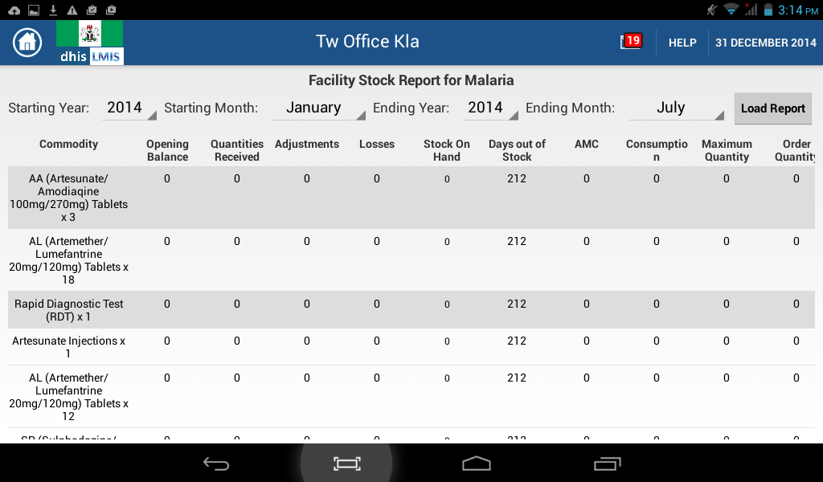

MODULE: BIN CARD

This module is used to provide an Electronic Bin Card for each commodity and provides details of stock movement and current Stock On Hand in the facility. Navigate to the module by tapping ‘Bin Card’ on the home page of the application.

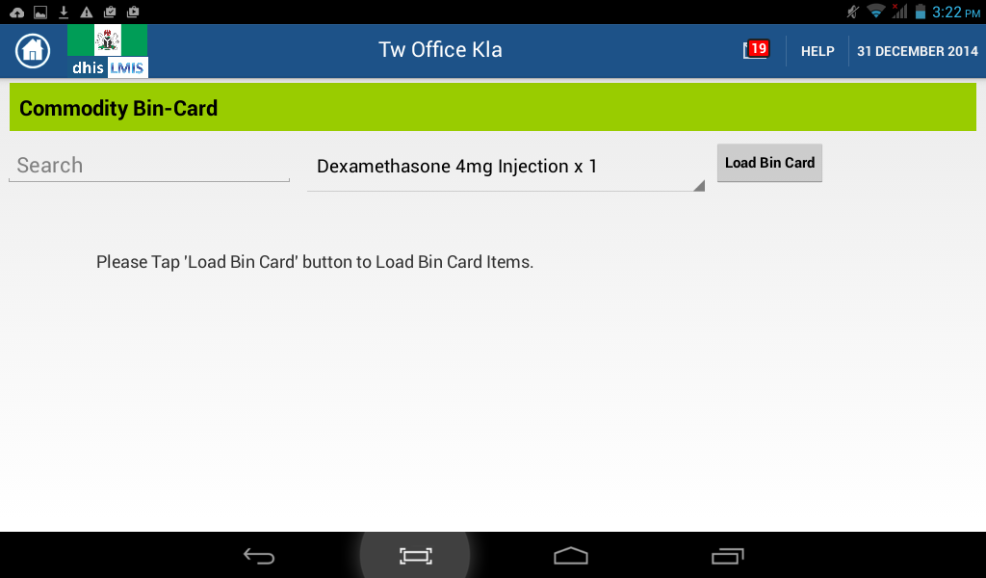

Select the commodity whose bin card you want to view either by using the search box or selecting it from the dropdown box and then tap ‘Load Bin Card’

A sample bin card is presented below:

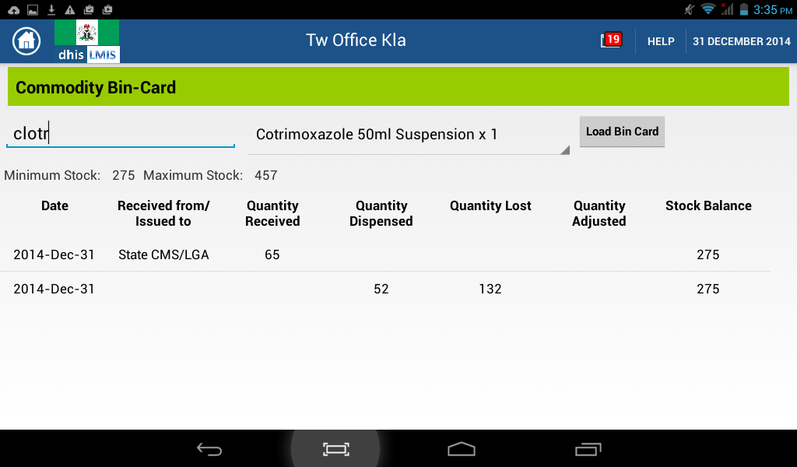

MODULE: MESSAGES

This module is used to view and act on all notifications within the application. It is divided into two:

1. Alerts which pop up when the amount of stock of a particular commodity are going below the Minimum level.
2. Notifications which are messages that require the user’s intervention.

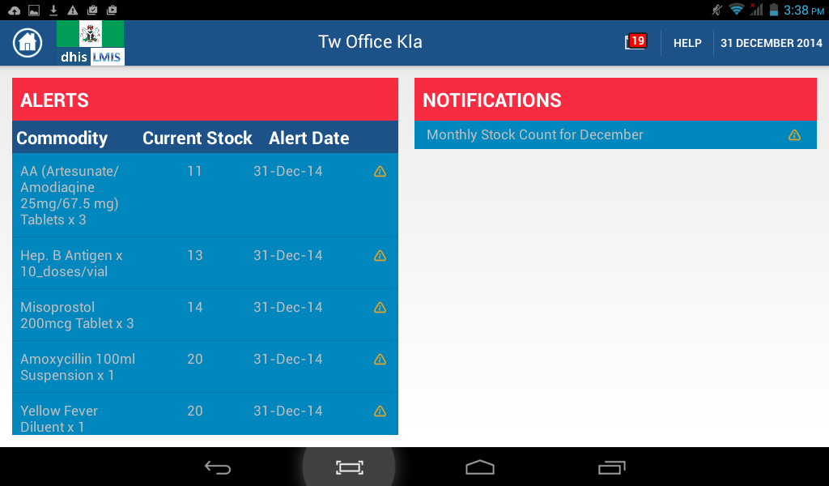  
**Types of alerts**

Low stock alert (represented in grey text)

Stock out alert (represented in red text)

**Types of notifications**

New Allocation notification

Monthly physical stock count alert

Routine order notification

Notification of no data entry

To act on an alert or notification, tap it and you will be redirected to the appropriate module where you can take action to resolve it.

When you select a low stock alert, you will be taken to the Order module with the quantities to order pre-populated and the type of order set to ‘Emergency’

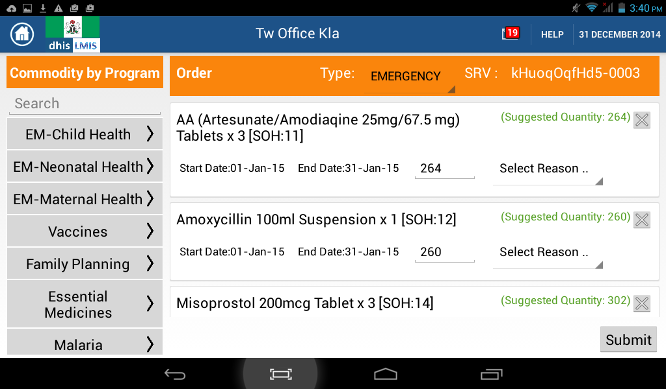

When you select a new allocation notification, you will be taken to the Receive module with the allocated commodities pre-populated and then you fill in the quantities received

When you select a Monthly Physical count alert, you will be taken to the Adjustments module with the reason for adjustment set to Physical count and all the commodities loaded, you then can fill in the actual quantities you found after counting.